**CHAPTER 1**

**INTRODUCTION**

**1.1** **Overview**

Jewelry has been an integral and almost essential part of all cultures—prehistoric to contemporary period. Jewelry with special powers is also part of folklore and mythology. That the modern technology can indeed endow jewelry with special abilities is the premise for this project. Today with advances in affordable miniaturization technologies and societal acceptance of wearable technical gadgets, it is possible to make jewelry that can incorporate sensors, actuators, and wireless communication chips to enhance human experience in daily lives. This is known as Cognitive Jewelry. While you probably feel safe at home with your security system, that feeling of protection may not extend far from your front door. This wearable device has a technology that can help offer you that sense of security no matter where you are. This device is being formulated for the society, especially for the safety of women, which is a major concern in today’s life. The device is used to provide flexibility and choices for the wearer.

**1.2 Motivation**

A United Nations statistical report compiled from government sources showed that more than 250,000 cases of rape or attempted rape were recorded by police annually; the reported data covered 65 countries. The above graph shows just the statistics of the number of reported rape cases in India so we can get a fair idea of how many cases must be reported all over the world.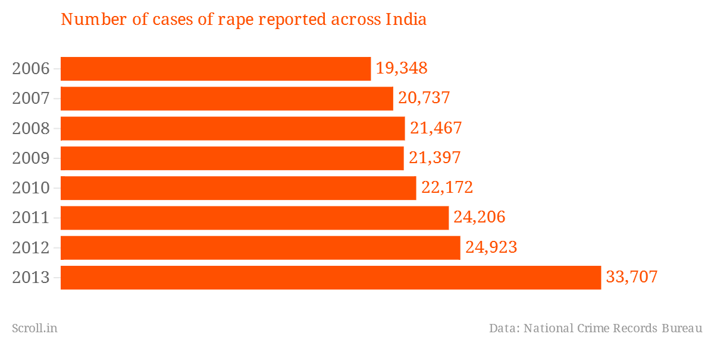

**Figure 1.1 Number of rape cases recorded in India**

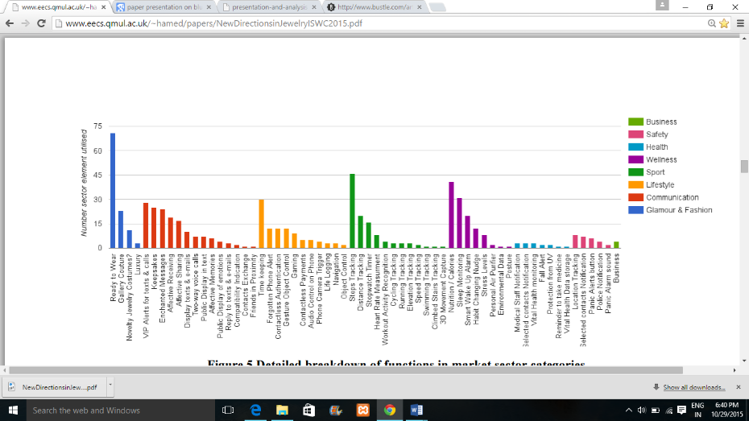

**Figure 1.2 Detailed breakdown of functions in market sector categories for wearable technologies**

The above graph represents the various fields in which wearable devices are used. We have taken up a project in the field of safety as you can see from the graph that there is very little contribution in this field. These factors have motivated us to explore this field and come up with a consumer friendly device which will help the society as well.

**1.3 Objective**

* To design a robust wearable product that works through gesture recognition, which can be implemented in the field of security.
* To understand the basic working of ARM Cortex Mo+ microprocessor and explore it’s working with different gesture oriented devices
* To understand and explore the working of Accelerometer and implement gesture sensing.
* To understand the working to BLE (Bluetooth Low Energy) and integrate it with different devices to meet Product goals
* To help each other in the team and overcome all the difficulties faced during the generation of the product.

**1.4 Scope**

This project will consist of creating a device based upon the use of motion-gesture sensing hardware to ensure the safety of the bearer. The project will be completed by May, 2016. Modules of the device include gesture sensing and remote connection to a handheld device which stays with the bearer to meet its requirements.

**1.5 Existing System**

The incidents of crime against women have been on the rise. Safety gadgets, pepper spray and other such things are available in the market but how feasible are they? If a girl is being attacked by a person how much time she gets to fetch the spray or any device from her bag and use it.

1. Artemis – A smart jewelry which sense danger just when the device is tapped 3 times. The device then starts audio recording and calls the emergency contacts to let them know your location. If you activate the sensor by accident, you just de-active this by using your smart phone.
2. Safelet- It is a fashionable device that notifies your contacts where you are. You activate it by clicking on the button located on the bracelet. The bracelet is connected to the smart phone via Bluetooth and is equipped with microphone so the attack can be audio recorded which can also be used as evidence in court trials
3. Amulyte- is a small pendant which can be worn as necklace. It can be activated by pressing on its help button and it has an embedded microphone and a speaker which allows two way communications. You can actually talk to your emergency contacts and give them even more information during the potential assault.
4. Cuff-The smart bracelet or necklace (available in several designs) has Bluetooth connectivity that links to your phone, so it will notify you of all important emails and alerts that you receive. But its bigger selling feature is its safety capability. If you press the Cuff for 2-3 seconds, it will send an emergency message to a network of people you've chosen, and they can view your location via GPS, coordinate via group text, or call 911.

**1.6 Proposed system**

Our Device is an innovative security device that you don’t need to press or squeeze to activate. It has embedded sensors that can measure any amount of force applied to the wearer, which is meant to identify signs of physical assault and send out a call for help. Even if certain levels of impact are part of your day to day life, this wearable security device can tell when the situation is violent enough to warrant a help alert. You can also connect it to your smart phone so as to identify your location using GPS.

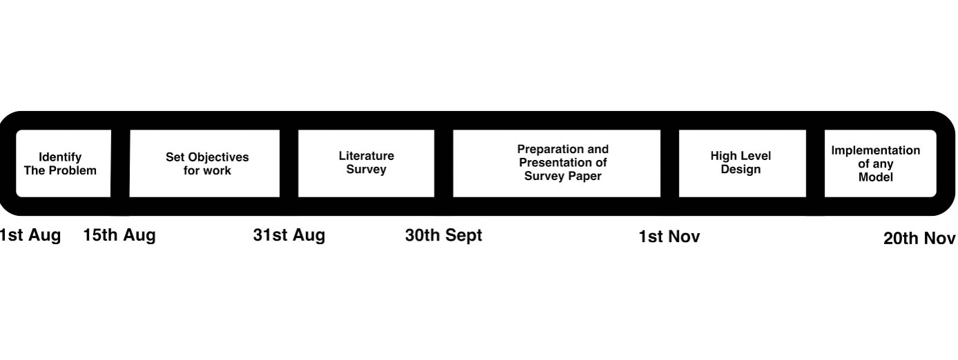**1.7 Work plan**

**Figure 1.3 Gantt chart**

We began our project by identifying the problem. By identifying the problem, we mean, researching on various gadgets or devices that provide safety and to realize how our device could be improved.

The next step was to decide what goals we want to achieve and how they can be met. We also researched on various papers in the same field as well as how the components we are using have already been implemented in various projects which helps us realize how efficiently we can use these components .

We plan to present a paper by next month which would be a reflection of the research done till date.

**CHAPTER 2**

**LITERATURE SURVEY**

Until today many devices exist which which made to ensure the safety of any individual, like, for example, as stated by Nudnik and Loriga[1], one of these products was ProeTEX. European project ProeTEX was led to incorporate wearable devices to improve safety and efficient disaster management techniques. This led to generation of “smart garments”. In these garments, wearable senses were integrated to monitor physiological parameters, position and the activity of the user. The major algorithms that are used, can be used as a major references to design a model which deals with the incorporation of different wearable sensors in different jewelry. The reason behind choosing a jewelry over a garment is to simply provide cost effectiveness to users. A jewelry can be donned for several days but a garment cannot be worn for several days continuously. Our device incorporates optimal use of various modules such as a Bluetooth Low Energy, an Accelerometer , and an handheld device. Each of these modules, serve a different yet pre-defined task which decide the overall functionality of the device. We will look at the different areas where these modules work one by one.

Our major component used here is the microprocessor ARM Cortex Mo+. This microprocessor serves as the CPU to the device, so it carries out all the basic calculations that are required. This microprocessor basically uses a RFID i.e. Radio Frequency Identification which works as a System-on-Chip(SoC). Additional information can be gained on the webpage[3]. The webpage gives a brief description of the Radio Frequency Identification (RFID) System-on-Chip (SoC). It describes the architectural features of the chip. The chip incorporates a 32-bit ARM Cortex M0 CPU which is highly capable of being flexible with much needed application performance. It supports the Bluetooth Smart protocol stacks. The flexible 31 mapping scheme make it a ultra-low power consumer and also makes it much more compatible with other Nordic microprocessors. This type of microprocessor is much needed to the design of the jewelry, as it will be incorporating minute impulses to response with an alert required by the user.

As stated by Stephen Brewster[2], Mobile and wearable computers present input/output problems due to lack of interaction techniques. The deals with generating new ways to interact with the day-to-day usable wearable devices. The article gives the major inspiration for introduction of gesture recognition design in the model. The also backs the major design motive for the device that is the safety issue. An evaluation of a range of different audio designs showed that egocentric sounds reduced task completion time, perceived annoyance, and allowed users to walk closer to their preferred walking speed. Secondly it also depicts a sonically enhanced 2D gesture recognition system for use on a belt-mounted PDA. An evaluation of the system with and without audio feedback showed users' gestures were more accurate when dynamically guided by audio-feedback.

We need to ensure that the microprocessors are typically algorithmically correct to carry out precise calculations and to log in a rather profound data. To ensure that the data is profound, Steve Mann, Jason Nolan and Barry Wellman[5] have proposed the use of Sousveillance or say inverse surveillance. According to them, using wearable computing devices to perform "sousveillance" (inverse surveillance) as a counter to organizational surveillance. A variety of wearable computing devices generated different kinds of responses, and allowed for the collection of data in different situations. Visible sousveillance often evoked counter-performances by front-line surveillance workers. The juxtaposition of sousveillance with surveillance generates new kinds of information in a social surveillance situation.

Now , at same time it is also important to program these algorithms correctly. The webpage[4] shows about the software development around a Nordic semiconductor environment. It shows the usage of nRF51 series versatile single board development kit by nRF51 DK and nRF51 dongle. This can be used to design specific task oriented algorithms to make the microprocessor in the desired way. The software tools help a lot to reach the goal to design the perfect model. The extra development tool chains and the mobile app development environment helps the microprocessors interact with mobile in a much easier and an effective way.

Now coming onto our next component, Bluetooth. Our research on various papers related to Bluetooth Low Energy (BLE) indicates that BLE is a better choice than Classic Bluetooth for several reasons.

The paper presented by Akhilesh G. Naik Microelectronics, ETC Dept., Goa College of Engineering, Goa University, India[6] explains SPP (Serial Port Profile) application for Classic Bluetooth and SPPLE for BLE, their configuration and functionality will help evaluate the Classic Bluetooth and BLE technology that can be used to connect devices wirelessly in an industrial setting.

SPP (Serial Port Profile) is used to the Bluetooth module and is used to set up virtual serial ports and connect two Bluetooth enabled devices. This application shows how to handle different call back events and utilizing the SPP module. This can be used to interface with a remote Client or Server. It uses two devices, one takes an initiative to connect to another device (initiator) and the other waits for a device to initiate a connection (acceptor). The SPPLE profile is similar to SPP profile except that it uses LE transport instead of BR/EDR transport. The BLE service can be registered using a console similar too Classic Bluetooth however the commands are different from the Classic Bluetooth since the function is based on the LE stack. Spectrum Analyzer was used to capture the Spectrums and to prove the data spectrum transmissions for SPP and SPPLE applications using Bluetooth and BLE stacks and showing the behavior of both the technologies. The graphs obtained from the spectrums show that for a particular frequency band the energy consumption for BLE is less than the Classic Bluetooth. Hence Classic Bluetooth can be used to for applications which require the transmissions of a continuous stream of data thereby eliminating cables for data updating and sending files on servers. On the other hand, BLE has the capability of sending data in episodes as when required over a certain frequency. Hence BLE is used in battery powered energy harvesting sensors in industries and when in monitoring applications.

Also BLE has several applications in various fields such as security, medicine, communication etc. Some of the applications are as below:

The paper titled – Development of Wireless Sensor Networks using Bluetooth Low Energy (BLE) For Construction Noise Monitoring [8] illustrates Bluetooth low energy (BLE) for the development of Wireless sensor networks (WSNs) for noise identification and sound locating. It employs networking protocols that uses raspberry pi as a gateway in the network. The functionality of the system is demonstrated and different WSNs are compared to understand the relative advantages of the BLE. This paper demonstrates the versatility of a BLE WSNs and the low power consumption that is achievable with BLE devices for noise detection applications.

Noise levels up to 80dB is tolerable, however, if noise exceeds 90dB then it’s very difficult for humans to tolerate it for long periods of time. The authors have taken into consideration the London Bridge Station where there is redevelopment taking place and hence there is a lot of noise from the construction happening about 86dB. However the highest noise is from the vehicle traffic such as trucks, cars, etc. which is about 100dB. To monitor such noise levels we need high sampling rate and low power consumption so the developed WSNs uses Bluetooth Low Energy (BLE) which is most suitable for this application. Bluetooth Classic has a higher power consumption and hence limits the battery life of the technology being developed. On the other hand, Bluetooth “Smart” also called Bluetooth low energy (BLE) has a low power consumption and a high communication range which makes it more suitable for noise identification technology. For our project we need both battery life and a high communication range and hence we prefer BLE over Bluetooth Classic. BLE WSNs advantage of low power consumption allows integration of energy harvesting technologies such as solar cells and energy vibration harvesters to increase their life time. However, employing such technologies in our device will not be cost effective.

The paper, Personnel Security System using Bluetooth Low Energy (BLE) Tag [7] proposes to design a personal security authentication system. The authentication is done on a fixed device and the identity is provided by the handheld device carried by every person. It uses a Bluetooth Low Energy (BLE) Tag which operates on a coin cell battery and keeps track of all the low energy devices or any other devices which supports BLE in the vicinity and keep track of when it entered and when it left the zone. The tag can also be used as a positioning device by measuring the received signal. This paper demonstrates the working of the authentication security system, once the battery is inserted in the BLE Tag it starts advertising its MAC address and the host BLE Tag scans for any advertisements which are nearby when the SCAN button on the BTOOL (it is the Bluetooth Low Energy PC Application, used to scan for advertisement packets broadcasted by the nearby BLE devices) is pressed. This working of the BLE tag is employed in the application where the BLE Tag is embedded in the door knob so only those persons who have the manual keys and Bluetooth Identification verification can open the door. The authentication is provided by the BLE Tag or the phone that supports BLE Tag. For our device we do not need the BLE to connect to several devices or check other handheld devices in the vicinity as we only need to connect the device to a single individual phone hence the BLE Tag would be unnecessary as it would require a lot more computations and is more complex.

This paper on Wireless Connectivity for Medical Monitoring [9][10] focuses on the widespread adoption of wireless technologies on medical applications which requires leveraging data transmission by using Bluetooth Low Energy (BLE) which link wireless sensors via radio frequencies to cell phones and computers. The data obtained can be analyzed that can help physicians manage diseases better.

In this paper Bluetooth features two implementations,” dual mode” and “single mode”. Single mode devices are compact radio communication units suitable for wireless medical monitors which are very small in size. Power consumption is low allowing the medical monitors to run for months or even years on coin cell batteries. Bluetooth low energy single mode devices can communicate directly with dual mode devices which are likely to be incorporated in next generation cell phones or in with any single mode devices. Dual mode are radio communication devices which are targeted with handsets and personal computers. They are intended to become more popular than the Classic Bluetooth because they offer much more functionality and are not very expensive. The most important functionality of cell phones or PCs with dual mode devices is that they can directly communicate with single mode devices. Hence, medical data can be sent from a wireless monitor to a handset or PC and from there to a remote physician. For our project, the device will likely incorporate Bluetooth low energy dual mode devices because they meet all the criteria of the requirements. We need our device to communicate with the user’s handset and hence dual mode is the best option.

We have also studied some other technologies comparing it to Bluetooth Low Energy (BLE) such as ANT/ANT+.

The paper[12],Presentation and analysis of a new technology for low-power wireless sensor network gives an overview of ANT/ANT+ and a comparison between ANT and two established standards: Bluetooth Low Energy (BLE) and 802.15.4/4a. The transmission range and rate of ANT and BLE are equal. In ANT we have two different nodes: a simple node (sensor) and a central node. Simple nodes collect the information and send it to the central node where it will be conserved. BLE is not compatible with classical version of Bluetooth. But, a node can implement a dual mode to be able to communicate with BLE or classic Bluetooth nodes. Our project needs to transmit the signal from the sensor to the user’s handheld device so we need to have a BLE to Bluetooth nodes communication and hence the most ideal technology to adopt is Bluetooth Low Energy (BLE) as it has a good frequency band and long battery life.

Another paper which compare BLE and ANT/ANT+ technologies is Presentation and analysis of a new technology for low-power wireless sensor network [10].This paper talks about the advent of a new MAC protocol designed for wireless sensors. ANT (Advanced and Adaptive Network Technology) and ANT+, which are widely being used today in wellness and sports domain, focus on bandwidth optimization while keeping very low energy consumption. When being compared to BLE(Bluetooth low energy) device the battery life of a device following the ANT protocol is thrice as much and the frequency bandwidth is the same but its maximum payload size is lesser, moreover the number of channels a BLE could support is much more than that supported by the ANT protocol

The paper titled – One Touch Alarm System For Women Using GSM[11] describes about a one touch alarm system for women’s safety using GSM. This helps to protect, identify and call friends or favourite contacts to help the one out of dangerous situations. Anytime you senses danger, all you had to do, is hold on the button of the device. The device consists of a PIC microcontroller, GSM module, GPS modules. The system resembles a normal watch which when activated, tracks the place of the women using GPS (Global Positioning System) and sends emergency messages using GSM (Global System for Mobile communication), to SOS contacts and the police control room. Whereas our project does not need any manual interaction of the user to activate the device. It automatically senses insecure environmental conditions with a help of an accelerometer which is a sensor used to detect when a person is being assaulted and this is in turn sent to the Bluetooth low energy (BLE) rather than using a GSM since the power consumption can be reduced to a large extent and is much affordable when compared to GSM module. Another paper [23] describes about an intelligent security system for women. This security system mainly consists of a monitoring device, the output of which is processed to identify insecure environments. This is identified using face recognition methods. Upon identifying unsafe environments system will send message to near-by control room and also turns on the alarms placed all around the area letting help from others. This system can be installed in public places such as railway stations, bus stands, foot paths and shopping mall, where women are commonly experiencing attacks. Our device uses the same principle but uses BLE and 3-axial accelerometer instead of face recognition methods and geared for an individual rather than an environment. Next we researched a similar paper titled- Emergency Application For Women[14][20] which depicts an alert system for PROB detection using commercially available electronic devices to both detect the PROB and alert authorities. We use an Android based smart phone with an integrated tri-axial accelerometer. Data from the accelerometer is evaluated with several threshold based algorithms and position data to determine a PROB. The threshold is adaptive based on user provided parameters such as: height, weight, and level of activity. The algorithm adapts to unique movements that a phone experiences. Our project too utilizes the tri-axial accelerometer which is evaluated with a threshold based algorithm which uses parameters such as: push, pull, kick and other such physical assaults done to a person for its activation. Similarly, a paper titled- A Review Of Accelerometer- Based Wearable Motion Detectors For Physical Activity Monitoring [8] reviews the development of wearable accelerometer-based motion detectors. The accelerometer measurement, sensor properties and sensor placements are introduced. Various research using accelerometer-based wearable motion detectors for physical activity monitoring and assessment, including posture and movement classification, estimation of energy expenditure, fall detection and balance control evaluation, are also reviewed. This is the same process which has been followed by our project to the various threshold value for the device to get activated by carrying out the accelerometer measurements and also by determining the sensor properties.

Next, a paper titled-A Wearable Accelerometer Based Platform to Encourage Physical Activity for the Elderly [19] depicts the growth in the elderly population which pose great pressure on the healthcare system to treat common geriatric problem. Preventive approaches like encouraging elderly people to perform physical exercises can decrease the risk of developing chronic diseases. In cases when diseases already have developed, further developments could possibly be retarded. In this work a wearable platform to recognize user’s movements is presented. The platform provides interactions with simple computer games designed to promote physical activity using accelerometers. Our device which is also a wearable device, detects the motion using accelerometers which does not incorporate simple computer games but determines a threshold value by various trial and error methods to activate the device which makes it unique than the wearable device described above in the paper.

Another paper[17] recognizes the use of an accelerometer, present inside every cellphone, to predict the activity (walking, climbing, sitting) of the owner. To implement this system labeled accelerometer data was collected from 29 users and then aggregated to predict the activity. The usage of a 3-axis accelerometer to measure the acceleration in all the three dimensions prompted us to take it up as one of our major components to help develop the system. The study of this paper helped us explore the greatly expanded domain while using a 3-axis accelerometer. Since our device also deals with gesture recognition, using an accelerometer, the various experimental results are a great asset.

The last paper titled- Activity Recognition using Cell Phone Accelerometers[13][24] they have described and evaluated a system that uses phone-based accelerometers to perform activity recognition, which involves identifying the physical activity performed by the user. To implement this, they collected labelled accelerometer data from people as they performed daily activities such as walking, jogging, climbing stairs, sitting, and standing, and then integrated this data into examples that summarize the user activity over 10- second intervals.

They then used the resulting data to induce a predictive model for activity recognition. Our project does not use a phone base accelerometers but uses 3-axis accelerometers which recognizes a range of threshold for the bodily movement when assaulted. This 3-axis accelerometer determines the range of accelerator is better than to use a phone-based accelerometer since it is much feasible than the latter.

Some other devices have been constructed which resemble our prototype: The first paper[21] talks about the implementation of wearable technology that is used to promote women safety. The device is to be worn on the wrist; it then detects the blood pressure, heart rate and temperature of a woman through embedded sensors. The microcontroller then compares these values with the normal conditions and sends appropriate messages if any abnormality is detected. Although the device is a big a step towards the implementation of wearable technology towards women safety, the product size is very big in comparison to a wristwatch and hence it can easily be spotted. This is because of the various number of components incorporated to develop the whole system. Secrecy of this device has to be jeopardized.

**“**Suraksha”, a device[20] used to avert critical circumstances to empower women safety is a technological masterpiece. This article gives us a review of that device. This device uses voice recognition to get activated. It contain a GSM module as a component which is self-sufficient to deliver messages to a smart-phone and even the location can be tracked because of the usage of a GPS module. The greatest advantage of using such a device is its ability to deliver messages without the usage of a smart phone (at the user end) by a single press of the button, but the inability to work without an actual physical contact is its greatest bane. This paper motivated us to develop the concept of building a device without any physical contact.

Some system which is being devised resembles a normal watch, but its functionality is far more. It has a GSM module and a GPS tracking module which is already installed, hence it does not require a smart phone (from the person at distressed end) to send messages, the GSM module is self-sufficient, moreover the Global Positioning System module keeps track of the location. The only flaw that it contains is owing to its activation. It needs an actual press of the button to get activated, but that sort of time may not be available in a real life scenario, hence we came up with the ideology to develop a system with does not require any physical contact.

**CHAPTER 3**

**REQUIREMENT ANALYSIS AND SPECIFICATION**

**3.1 Functional Requirements**

**Regulatory/Compliance Requirements**

* The accelerometer must define the threshold values to detect an assault.
* The BLE should form a reliable connection with the handheld device.
* The space and time complexity of algorithms must be low to carry out calculations in the nick of a time.

**Interface requirements**

* The Handheld device must recognize the messages sent through BLE.
* The Accelerometer and BLE must be coordinated to provide precise data.
* The Microprocessor must calculate the gestures and keep a log of data.

**3.2 Non-Functional Requirements**

**Ease of Use-** This device must not require any kind of external physical contact such as pressing or squeezing to be activated, any act of physical violence can be automatically detected by embedded sensors and messages are then delivered through your smartphone.

**Size-** Since it must fit inside a pendant, the size is diminutive. Being diminutive, the actual purpose of the device is hidden. Hence secrecy would also be maintained.

**Portability-** As a device its functionality is accomplished only if worn as a jewelry and this makes it important that the device must be portable which means the device is always attached to the user.

**Robustness-** The device must be robust to ensure no damage in case of falling.

**Reliability-** This device should guarantee quick activation and ensures that the message must be delivered to the authenticated person.

**3.3 Hardware Requirements**

* ARM Cortex MO+ (Nordic 51822)
* 3-Axis Accelerometer
* BLE(Bluetooth Low Energy)
* Handheld Device
* Batteries

**3.4 Software Requirements**

* Keil C166 Development Tools
* 32 bit Operating System (Windows/MAC)
* Bluetooth SDKs

**3.5 Cost Estimates**

| **Part of the Device** | **Quantity** | **Price** | **Total** |
| --- | --- | --- | --- |
| **Arm Cortex Mo+**  **microprocessor** | 1 | ₹300 | ₹300 |
| **Bluetooth Low**  **Energy** | 1 | ₹300 | ₹300 |
| **3-axis Accelerometer** | 1 | ₹300 | ₹300 |
| **Total** |  |  | ₹900 |

**Table 3.1 Cost Estimates**

**CHAPTER 4**

**DESIGN**

**4.1 High Level Design**

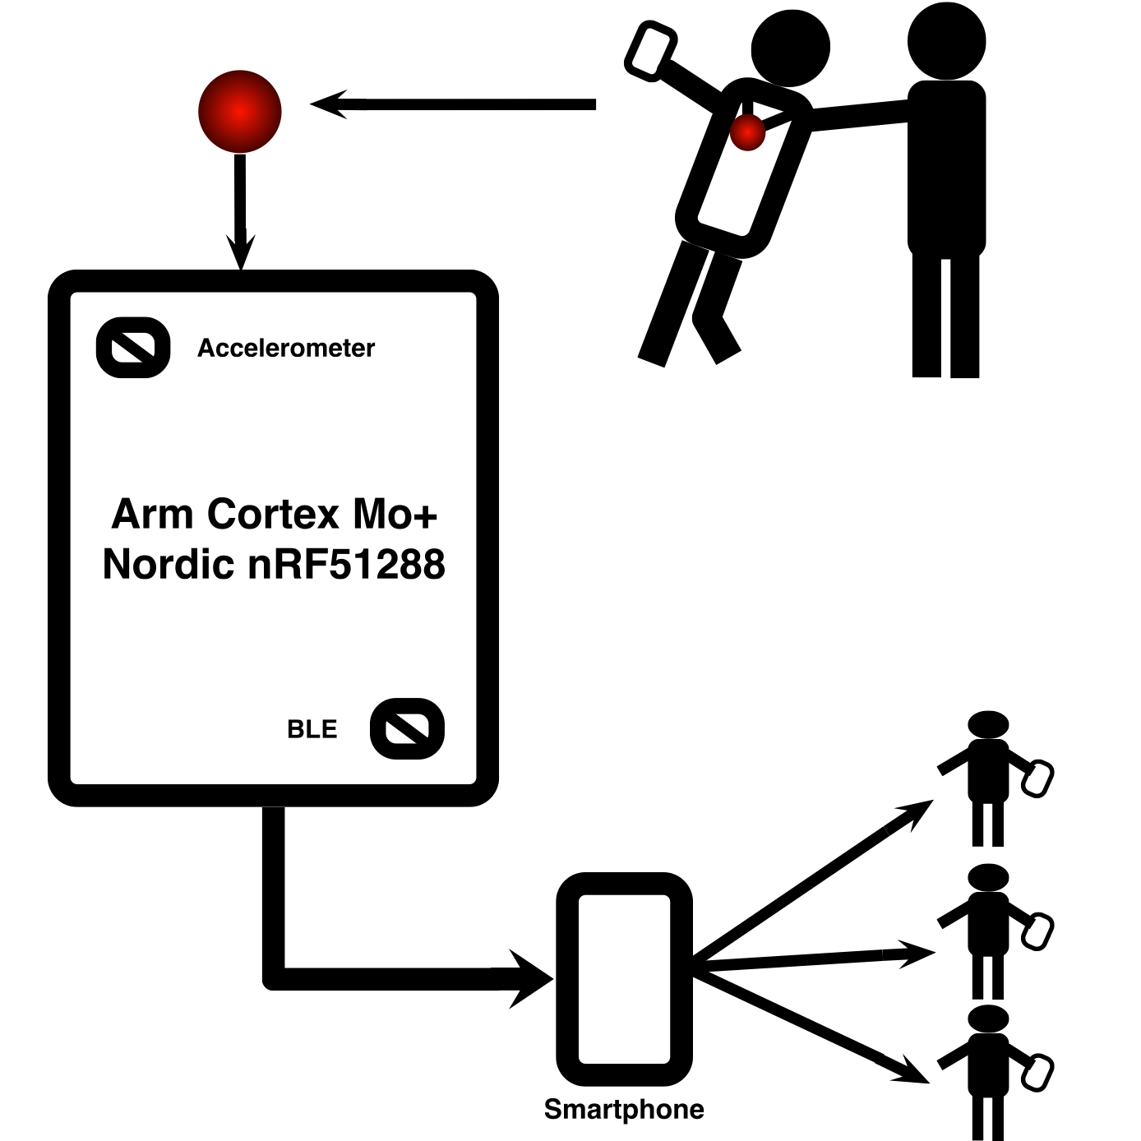

**Figure 4.1 Block diagram of the device**

**4.1.1 System architecture**

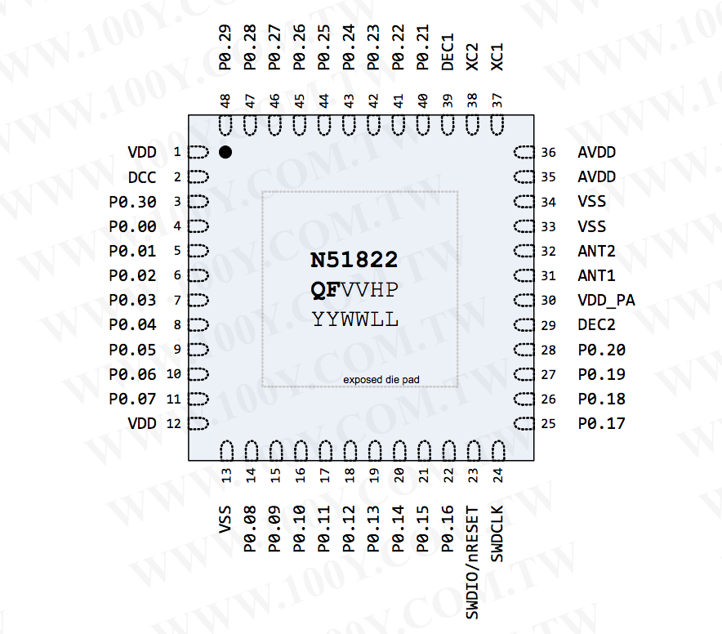

**Figure 4.2 Pin Structure of the Arm Cortex Mo+**

**4.1.2 Abstract Specification of Sub Systems**

Accelerometer - A 3-Axis accelerometer for motion based gesture recognition.

Bluetooth Low Energy - Bluetooth device to generate connection between handheld device and microprocessor.

Arm Cortex Mo+ - A microprocessor to log data and to carry out necessary calculations.

Handheld Device - A handheld device to maintain connection through Bluetooth.

**4.2 Methodology**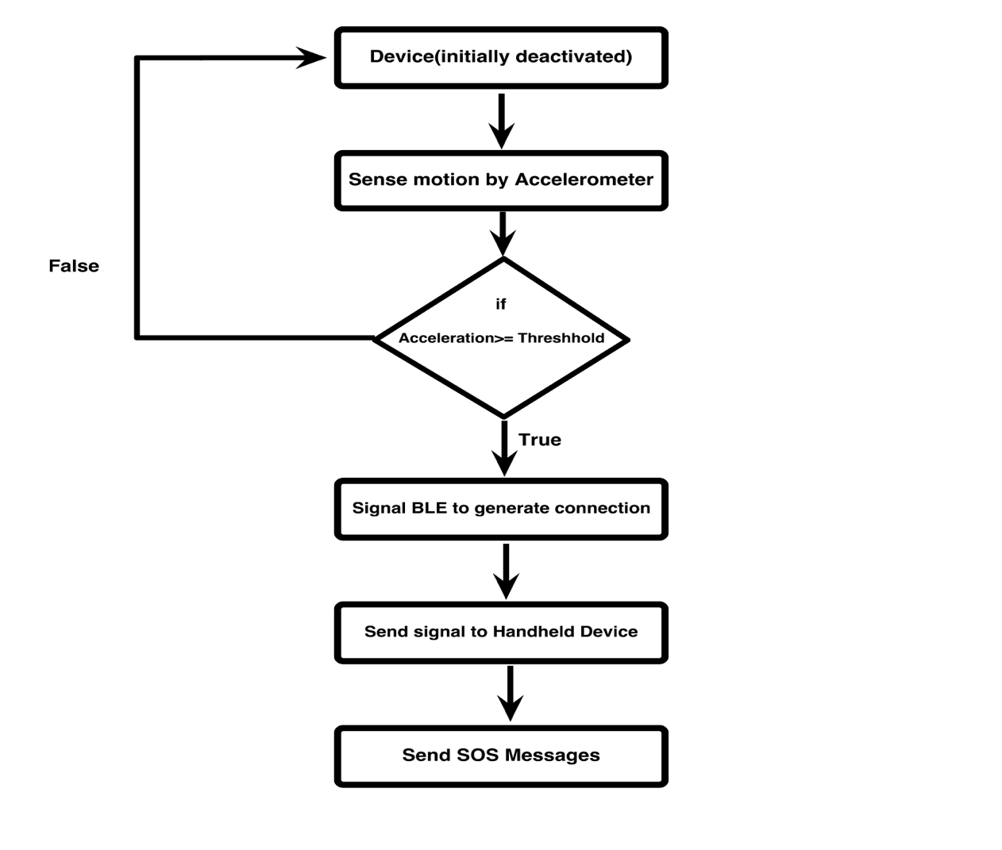

**Figure 4.3 Flowchart of the device**

**CHAPTER 5**

**CONCLUSION AND FUTURE ENHANCEMENTS**

**5.1 Conclusion**

* With the use of such wearable devices we can achieve more responsiveness which makes the user be completely dependent on this device during an emergency and the person be less worried about the insecure environment.
* It's fashionable which makes it really very trendy and cool and can be worn with almost anything. Moreover, it is also portable and light in weight which makes it a very consumer friendly device.
* Finally it can be really an inspiration for engineers to build such safety devices with better features in the future
* It is very important, one keeps in mind that the best protection you can give yourself is to avoid potentially dangerous situations as much as possible. After all, it is often said that prevention is better than cure. So try as much as possible to avoid being a victim of crime, and a great way to achieve this is to have a high level of technological security awareness or consciousness.

**5.2 Future Work**

* In future, a 6- axis accelerometer could be used to provide much precise and wider information in gesture recognition. It could be a lot more powerful when compared to the tri-axial accelerometers.
* A geo tagged data logging could be used in which the mapping of the location could be much precise and also sending in the data to the nearest police station or a friend could be implemented which can be achieved easily using the geo tagged data logging.
* Algorithm can be optimized to implement inverse surveillance.
* This wearable security device can be either implemented as an earring, or a hair clip or any such kind of an accessory which doesn't attract the attacker but at the same time do its job without any problem.

**REFERENCES**

[1]Stephen Brewster,”Multimodal 'eyes-free' interaction techniques for wearable devices”, 2003

[2]Steve Mann, Jason Nolan and Barry Wellman,” Sousveillance: Inventing and Using Wearable Computing Devices for Data Collection in Surveillance Environments.”,2003

[3]Sabri Khssibi, Hanen Idoudi, Adrien Van Den Bossche, Thierry Val and Leila Azzouz Saidane,” Presentation and analysis of a new technology for low-power wireless sensor network”, May 2009

[4]Josie Hughes, Jize Yan and Kenichi Soga Cambridge University Engineering Department, Trumpington Street, Cambridge, CB2 1PZ, UK,” Development Of Wireless Sensor Network Using Bluetooth Low Energy (BLE) For Construction Noise Monitoring”, June 1, 2015

[5]Akhilesh G. Naik Microelectronics, ETC Dept., Goa College of Engineering, Goa University, India,”Evaluation and Comparison of Classic Bluetooth and Bluetooth Low Energy (BLE) for Industrial Applications” , 3 March 2015

[6][Alf Helge Omre](http://www.ncbi.nlm.nih.gov/pubmed/?term=Omre%2520AH%255Bauth%255D), BTech–EEE, Nordic Semiconductor, Oslo, Norway, “Bluetooth Low Energy: Wireless Connectivity for Medical Monitoring”, March 1, 2010

[7]K.Gautham, G.Raghav, N.R.Raajan, Department of ECE, SEEE, SAST1RA University Thanjavur, Tamil Nadu, India,” Personnel Security System using Bluetooth Low Energy (BLE) Tag”, May 2014

[8]Curone, Nudnik, Loriga and more,”Smart Garments for Safety Improvement of Emergency/Disaster Operators” Aug, 2007

[9]Activity Recognition using Cell Phone Accelerometers Published by: Jennifer R. Kwapisz, Gary M. Weiss, Samuel A. Moore Department of Computer and Information Science, Fordham University.

[10]Premkumar, CibiChakkaravarthi, Keerthana, Ravivarma, Sharmila, One Touch Alarm System For Women’s Safety Using GSM , 01, March 2015, Volume No. 04.

[11]Remya George, Anjaly Cherian.V, Annet Antony, Harsha Sebestian, Mishal Antony, Rosemary Babu.T,” An Intelligent Security System for Violence against Women in Public Places”, April 2014 Volume-3, Issue-4. ISSN: 2249 – 8958 (IJEAT)

[12]Mr.Magesh Kumar, Mr.Raj Kumar, IPROB – “Emergency Application For Women”, March 2014. Volume 4, Issue 3. ISSN: 2250-3153

[13]Che-Chang Yang and Yeh-Liang Hsudoi “A Review of Accelerometry-Based Wearable Motion Detectors for Physical Activity Monitoring”, 2010 Aug 20, 10.3390/s100807772 PMCID: PMC323118

[14]Kumar Kandukuri, A. Amala Jency, R. Anita, K.S. Pavithra, V. Seema, “Android Based Women Safety Application with Blood Pressure, Heart Beat Monitoring and Location Tracking, Emergency Support System”, IJSRD - International Journal for Scientific Research & Development| Vol. 3, Issue 01, 201

[15]Jennifer R. Kwapisz, Gary M. Weiss, Samuel A. Moore, “Activity Recognition using

Cell Phone Accelerometers”, Department of Computer and Information Science Fordham University

[16]Nishant Bhardwaj and Nitish Aggarwal, Design and Development of “Suraksha”-A Women Safety Device, International Journal of Information & Computation Technology. ISSN 0974-2239 Volume 4, Number 8 (2014).

[17] “New Directions in Jewelry”: a Close Look at Emerging Trends & Developments in Jewelry-like Wearable Devices Yulia Silina, Hamed Haddadi Cognitive Science Research Group Queen Mary University of London, UK

[18] Chen KY, Bassett DR., Jr The technology of accelerometry-based activity monitors: Current and future.Med. Sci. Sports. Exerc. 2005;37:490–500.

[19] Mathie MJ, Coster ACF, Lovell NH, Celler BG. Accelerometry: providing an integrated, practical method for long-term, ambulatory monitoring of human movement. Physiol. Meas. 2004;25:1–20.

[20] Morris JRW. Accelerometry—A technique for the measurement of human body movement. J. Biomech.1973;6:729–736

[21] Godfrey A, Conway R, Meagher D, ÓLaighin G. Direct measurement of human movement by accelerometry. Med. Eng. Phys. 2008;30:1364–1386.

[22] Karantonis DM, Narayanan MR, Mathie M, Lovell NH, Celler BG. Implementation of a real-time human movement classifier using a triaxial accelerometer for ambulatory monitoring. IEEE. Trans. Inf. Technol. Biomed. 2006;10:156–167.

[23] Sabri Khssibi, Hanen Idoudi, Adrien Van Den Bossche, Thierry Val and Leila Azzouz Saidane, Presentation and analysis of a new technology for low-power wireless sensor network International Journal of Digital Information and Wireless Communications (IJDIWC) 3(1): 81-92,The Society of Digital Information and Wireless Communications, 2013 (ISSN: 2225-658X).

[24] “Introduction to nRF51288” URL: “https://www.nordicsemi.com/eng/Products/Bluetooth-Smart.../nRF51822”

[25] “Development tools for nRF51288” URL: “https://www.nordicsemi.com/eng/Products/Bluetooth-Smart-Bluetooth-low-energy/nRF51822”

BMS College of Engineering.

Department of Computer Science and Engineering.

Batch no. : 15 Date: 26-11-2015

Project Title: Cognitive Apprehensive Device

|  |  |  |
| --- | --- | --- |
| **PROGRAM OUTCOMES** | **Level**  **(High/Low)** | **Justification if addressed** |
| **PO1** | High | The device we are implementing requires an algorithm which is computationally extensive and requires the knowledge of computer science, mathematics and engineering fundamentals. |
| **PO2** | High | To implement the device we need to analyze and understand the basics of engineering, mathematics and computer science |
| **PO3** | High | A high level design of product has been conceptualized as a solution for the problem statement. |
| **PO4** | High | The design and the work flow have been compiled together after analyzing various papers on the topic at hand. |
| **PO5** | High | Comparison of various available resources and narrow down only to the most effective ones. |
| **PO6** | High | Our device has a relevant impact on the society as it is addressing a serious issue regarding safety of women. Hence we are exhibiting our responsibilities as engineers. |
| **PO7** | High | The device is a clear example of societal improvement and sustainable development by providing safety to women. The main areas of concern for us have great scope for development. |
| **PO8** | High | Our device follows all the norms of professional ethical practices ethically. |
| **PO9** | High | Each of the teammates have done their part and helped compile the entire documentation required for the project. |
| **PO10** | High | The documentation and presentation has given us an idea about how a particular idea can be materialized. |
| **PO11** | High | The use of hardware components along with basic principles of programming learnt by us helped us produce this cost effective product. |
| **PO12** | High | The technologies under consideration evolve everyday for which all of us need to constantly update ourselves for better understanding. |

Submitted by:

USN NAME SIGNATURES

IBM12CS079 Pronoy Dalal

IBM12CS082 Prerna Bajaj

1BM12CS088 Raksha Desai

1BM12CS138 Vardaan Tyagi